# Answers to Questions from TT 6.1

Name: Minh Nguyen

Student ID: 104309099

**Hand execution using a trace table.**

*Demonstrate how the following code is executed in the computer.*

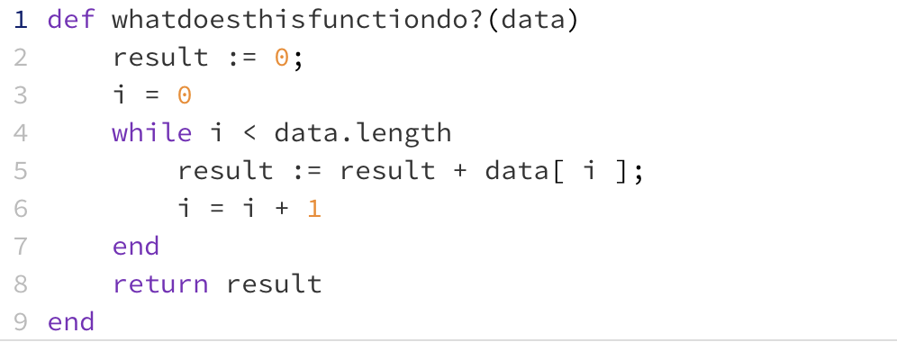

Draw and complete a trace table for the following two sets of data and place the final result in the table below:

|  |  |
| --- | --- |
| **Data** | **Result** |
| [6, 3, -3, 8, 1] | 15 |
| [2, 6, -2, 3] | 9 |

**Once you have completed your trace tables (below) write the name you chose for the function above:**

calculate_sum

**Place your trace tables below:**

**For data set: [6, -3, 3, 8, 1]**

|  |  |  |
| --- | --- | --- |
| **i** | **Data[i]** | **Result** |
| 0 | data | 0 |
| 0 | 6 | 6 |
| 1 | -3 | 3 |
| 2 | 3 | 6 |
| 3 | 8 | 14 |
| 4 | 1 | 15 |

**For data set: [2, 6, -2, 3]**

|  |  |  |
| --- | --- | --- |
| **i** | **Data[i]** | **Result** |
| 0 | data | 0 |
| 0 | 2 | 2 |
| 1 | 6 | 8 |
| 2 | -2 | 6 |
| 3 | 3 | 9 |